

**BE 5309 -013**

**Human Physiology in Bioengineering**

**Coupled Sweat Sensors for Multipurpose Monitoring for Athletes**

**Dhineshvikram Krishnamurthy-1001237384 Gokul Ramanan Pandiaraj-1001237366 Harish Kumar Vasikaran-1001231099**

**Abstract:**

Wearable devices are the replacing the conventional health monitoring system. It improves the quality of life and aid in our day to day activities. Technology advancement in sports medicines will enhance the efficiency and performance of an athlete. Sweat and joint mechanics are key factors for evaluating and improvising the training regime. The proposed sensor system is capable of real time monitoring of electrolytes and lactic acid in sweat along with measuring the joint angles involved during physical activity. These parameters are continuously monitored in a hand held device making the system portable.

**Introduction:**

***Objective:***

The main objective of the device is to assist the athletes completing in aerobic and anaerobic sports. These sports activity can lead to dehydration and fatigue of the muscles [1]. Apart from this even the analysis of body movement plays a significant role in improvement the performance. However, most athletes undermine the importance of monitoring how much they are hydrated and tiredness of muscle. In most cases the athlete won’t even know they are in danger of dehydration and fatigue. If it’s not monitored and no action is taken the athlete’s performance significantly. This gives a need for real time sensor which is capable for measuring the hydration level, muscle fatigue and the body posture in real time. Using the information trainers will how to prevent sport injury.

***Sweat:***

One of the main analyte used in the measure dehydration and muscle fatigue sweat [2]. Sweat are watery substance secreted by the sweat glands seen on the surface of the skin. Reasons by which someone could sweat include physical activity, high atmospheric temperature and even emotional conditions [3]. However, sweating is good as it enables to regulate the body temperature. Coming to composition, sweat is mostly water where minerals and lactic acid are dissolved into it. Minerals include sodium and potassium. By measuring the concentration of sodium and potassium we can determine the hydration level of the body whereas by measuring lactic acid we can measure the muscle fatigue level [5].

***Sweat analysis for athletes:***

Athletes are prone to fluid loss during their training in the form of sweat. It will increase the risk of muscle fatigue, heat stroke, dehydration also affect their performance. Over-drinking also will have negative effects during training session. Monitoring sweat is vital to control these factors and maintaining electrolyte and fluid balance [7]. Sweat monitoring will determine the fluid loss, muscle fatigue, electrolyte content, dehydration state during training. Hence endurance, body fat utilization can be improved by monitoring sweat [5]. Monitoring body temperature is vital in detecting thermoregulation, fatigue, muscle cramp, etc.,

***Joint movement:***

Joints are the connections made for the bones which allows for different angles of body movement. There are various joints in our body. But the most important joints used in rigorous physical activity is the knee joint and the shoulder joint [4]. These joints are strong and can withstand a lot of physical load. Knee joints come into play in any sort of running activity, and the shoulder joint is used for pulling or pushing movements. Even though these joints are powerful they could be injured if they are swang at an angle beyond their capability. There are many cases where athletes careers were ruined due to joint injury. If we were to measure the joint movements angles in real time, we can study how top athletes like Usain Bolt runs, and using these information trainers can come up with novel techniques to train new athletes and minimize the injury rate.

***Running posture Analysis for athletes:***

Analyzing running mechanics will help to improve the efficiency and speed for an athlete. Motion analysis will help to reduce injury rate of athletes by overcoming their weakness [9]. The running posture of top athletes can be compared to improve overall performance also help to reduce joint pain due to improper angles of joint movements during training.

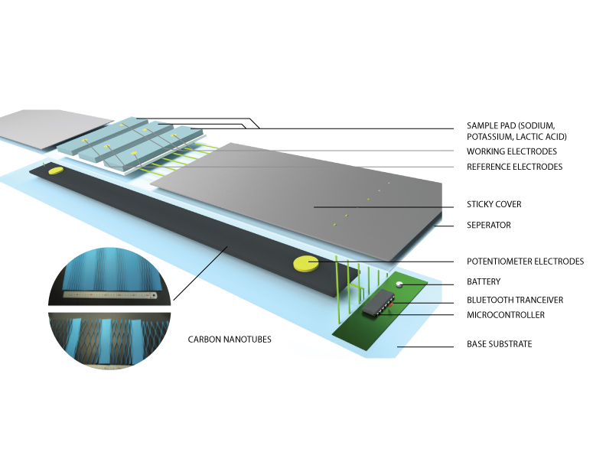**Concept Design:**

**Figure 1: 3D Block diagram of the Coupled sweat sensor and motion sensor** (designed in blender 3D)

***Components:***

Figure 1 show the different parts of the sensor and the components.

1. Sample pad – made up of super absorbent hydro gel. The pad is divided into three sections to monitor Sodium, Potassium, Lactate level respectively.
2. Transducer - Lactate, Potassium, Sodium electrodes – coated with Lactate Oxidase Similarly, the respective enzymes for Potassium and Sodium are coated to the respective ion selective electrodes (ISE)Signal Detector. Each of the these has a Reference electrode and a working electrode for carrying current and detect. These sections are designed in such a way that it sticks firmly to the skin [5].
3. Outer covering which is helpful in protecting t the underlying electrode and helps in sticking the sensor to the human body.
4. Carbon Nanotubes - Vertically aligned and very sparse SWCNT thin films were first grown from patterned catalysts using water-assisted chemical vapor deposition. To make long films of arbitrary length, films were individually removed and laid side by side, with a 1 mm overlap, onto a flat elastomeric dog-bone-shaped substrate poly dimethyl siloxane, PDMS; thickness, 1 mm, with the alignment of the SWCNTs arranged perpendicular to the strain axis [10].
5. Separator – A layer which divides the top sweat sensor layer from the bottom motion sensor.
6. Transmitting electrodes which acts as potentiometer are helpful in placing carbon nanotubes in position to the base substrate.
7. Battery – which provides energy to the motion sensor for potentiometric measurement and to the sweat sensor for the electrochemical reaction and powers the microprocessor.
8. Microprocessor - Transmitting and receiving signal to the sweat sensor and the motion sensor
9. Bluetooth transceiver – Transmits the signal received from the sensors to the nearby synchronized devices.
10. LM35 nanochip - Measuring the temperature of the body.

**Working:**

***Sweat sensors:***

The basic principle behind the working of sweat sensors is electrochemical reaction. The component of the electrochemical sensor has a reference electrode, working electrode and a ground electrode. When the analyte (e.g.: Sweat) reaches the region of electrode, redox reaction will occur resulting in flow of electrons. E.g. In this case Lactate transducer is coated with Lactate Oxidase [6]. This enzyme upon reaction with Lactate which is present in the sweat, Lactate Oxidase will get converted into two free electrons which produces current that is proportional to the concentration of lactate in the sweat. This current is later amplified for better signal detection [7][12].

***Motion sensor:***

The principle used in this sensor is Potentiometry. A potentiostat is a control and measuring device. It comprises an electric circuit which controls the potential across the cell by sensing changes in its resistance, varying accordingly the current supplied to the system: a higher resistance will result in a decreased current, while a lower resistance will result in an increased current, to keep the voltage constant as described by Ohm’s law [11]. When the Carbon nanotubes are stretched, the length will increase and the area will decrease. This will result in increase in resistance where the flow of current will be low. This is given by the equation R=ρ * L / A, where ρ= resistivity of the material (CNT), L = Length of the tube, A = Area of the tube.

**Data Processing:**

The appropriate measure current will directly correspond to the concentration of the chemical compounds present in the sweat and the angle of flexion. In the case of sweat sensor, the current generated by each of the sample pad is directly proportional to the concentration of the substance present in sweat. The current obtained is transmitted to the mobile app by Bluetooth transceiver with the help of microprocessor which will display equivalent molar concentration of each electrolytes.

In the case of motion sensor detection, the current at that point of nth second time is transmitted. Upon comparing with the (n-1)th current, change in current will be calculated which is proportional to the amount of stretch made by the muscles. The obtained data is compared with a set of previously analyzed ideal athlete’s data and the performance is predicted based on them. Figure 2. shows the change in resistance during different activities Extending, Flexing, Marching, Squatting, Jumping [10].

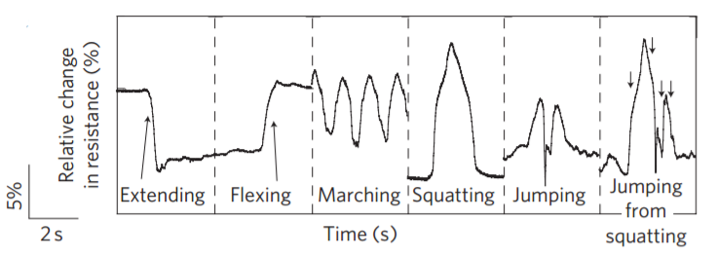

**Figure 2: Shows relative changes in variation during extending, flexing, marching, squatting, jumping, jumping from squatting [10]**

Figure 3. shows the positioning of the sensor strips on legs and hands. The strips are placed intentionally in these regions reason because, the response of sweat sensor and motion sensor. This is due to maximum sweat will get released in the region of shoulder deltoids and leg’s popliteus muscles and maximum flexing and extension can be sensed.

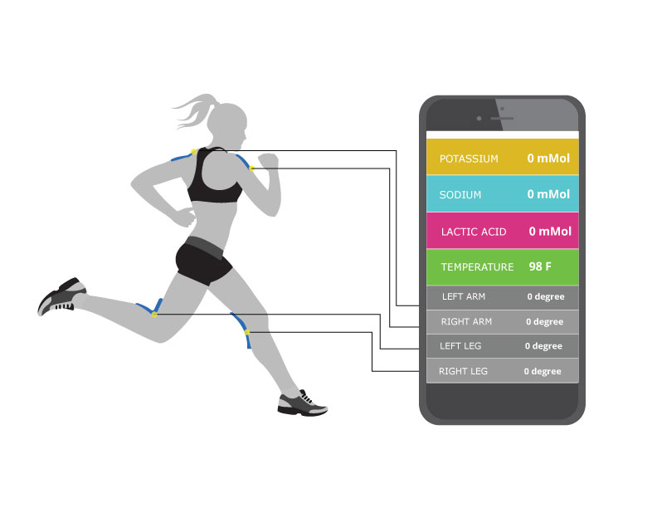

**Figure 3: Shows the placement of sensors strips shoulder deltoids & leg’s popliteus muscle and the response obtained from them is showed in the mobile application.** (designed in Adobe Illustrator)

**Timeline:**

|  |  |
| --- | --- |
| **Phase** | **Duration (months)** |
| Hardware Design | 3 |
| Mobile Application Development | 1 |
| Calibration | 2 |
| Testing | 2 |
| Troubleshooting | 1 |
| Federal Trade Commission (FTC) Approval | 3 |
| Manufacturing | 4 |

**Cost analysis:**

|  |  |
| --- | --- |
| **Component** | **Cost** |
| Sensor Kit | $ 35 |
| Microprocessor | $ 15 |
| Carbon Nanotubes | $ 30 |
| Hardware | $ 20 |
| Miscellaneous | $ 30 |
| ***Total Cost*** | ***$130*** |

**Reference:**

1. Sports-Related Dehydration-Topic Overview. (n.d.). Retrieved December 02, 2016, from <http://www.webmd.com/fitness-exercise/tc/sports-related-dehydration-topic-overview>
2. Bates, Graham P., and Veronica S. Miller. "Sweat Rate and Sodium Loss during Work in the Heat." Journal of Occupational Medicine and Toxicology 3.1 (2008): 4. Web.
3. Montain, Scott J., Samuel N. Cheuvront, and Henry C. Lukaski. "Sweat Mineral-Element Responses during 7 H of Exercise-Heat Stress." International Journal of Sport Nutrition and Exercise Metabolism 17.6 (2007): 574-82. Web.
4. Saladin, Ken. Anatomy & Physiology. 7th ed. McGraw-Hill Connect. Web.
5. Heikenfeld, Jason. "Sweat Sensors Will Change How Wearables Track Your Health." *IEEE Spectrum: Technology, Engineering, and Science News*. N.p., 2014. Web. 02 Dec. 2016.
6. Munje, Rujuta D., Sriram Muthukumar, Anjan Panneer Selvam, and Shalini Prasad. "Flexible Nanoporous Tunable Electrical Double Layer Biosensors for Sweat Diagnostics." *Scientific Reports* 5 (2015): 14586. Web.
7. Ghovanloo, Maysam, and Xueliang Huo. "Wearable and Non-Invasive Assistive Technologies." *Wearable Sensors* (2014): 563-90. Web.
8. Liu, Gengchen, Kyle Smith, and Tolga Kaya. "Implementation of a Microfluidic Conductivity Sensor — A Potential Sweat Electrolyte Sensing System for Dehydration Detection." *2014 36th Annual International Conference of the IEEE Engineering in Medicine and Biology Society* (2014): n. pag.Web.
9. "How to Run: Running with Proper Biomechanics." *Science of Running*. N.p., n.d. Web. 02 Dec. 2016.
10. Yamada, Takeo, Yuhei Hayamizu, Yuki Yamamoto, Yoshiki Yomogida, Ali Izadi-Najafabadi, Don N. Futaba, and Kenji Hata. "A Stretchable Carbon Nanotube Strain Sensor for Human-motion Detection." *Nature Nanotechnology* 6.5 (2011): 296-301. Web.
11. "Potentiostat Fundamentals." *Potentiostat-Instrument Between Working Electrode/Reference Electrode*. N.p., n.d. Web. 02 Dec. 2016.
12. "Electrochemical Reaction." *Encyclopedia Britannica Online*. Encyclopedia Britannica, n.d. Web. 02 Dec. 2016.